**MATCH THE PICTURES WITH THE WORDS!**

* **CAP SUNGLASSES**

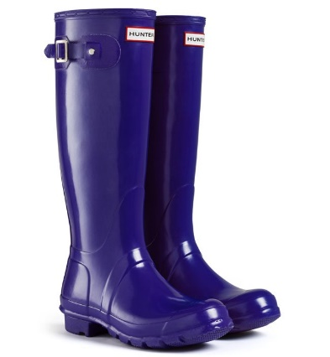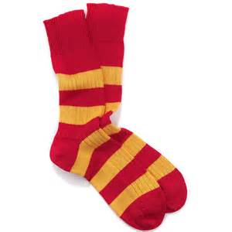

* **SKIRT HELMET**

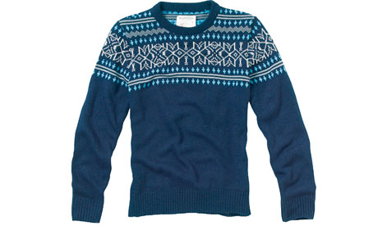

* **WELLIES**

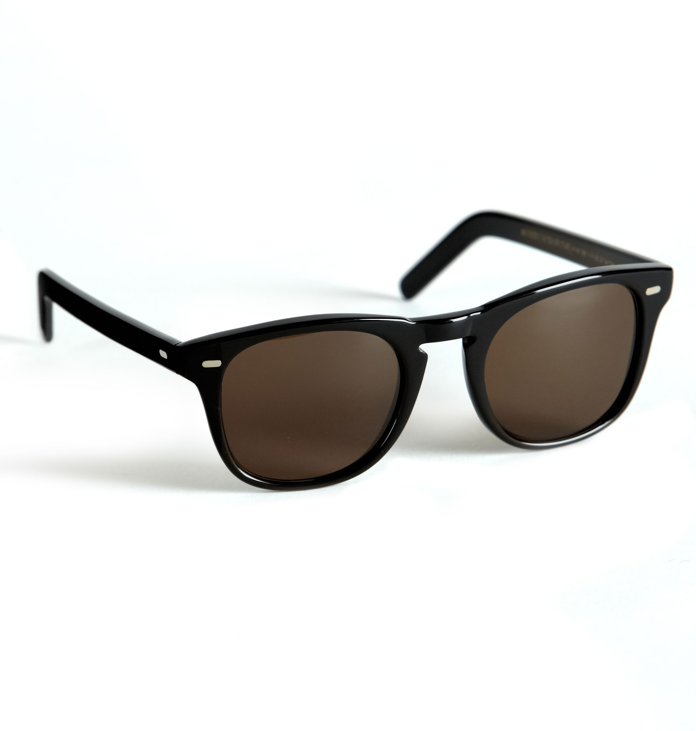

* **JUMPER SOCKS**

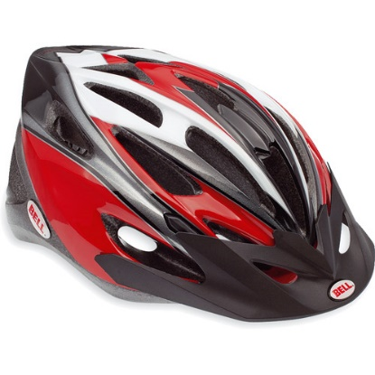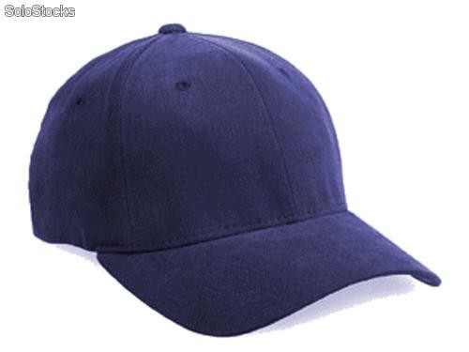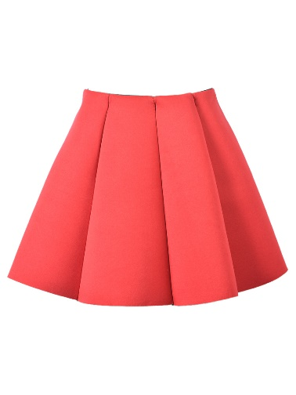

**Fill in the missing letters!**

* 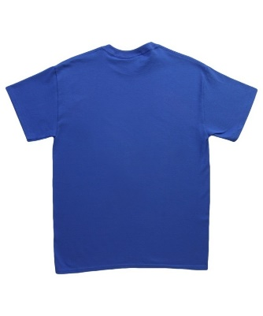**T- SH_RT**
* 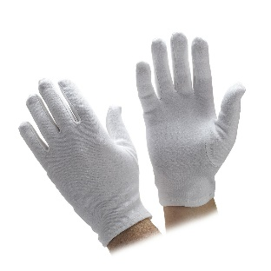**G_OVE_**
* 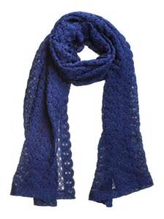**SC___F**

**Colours- Match the colours**

**RED**

**GREEN**

**BROWN**

* **P_RP_E**
* **YE__OW**
* **OR_NG_**